**WEEK 13: Assignment**

* **Use this file as a template and fill in the answers.**
* **Save the file as WEEK _13_BID-19006 according to your roll number.**
* **THE DATE OF SUBMISSION IS WRITTEN ON THE TOP RIGHT CORNER.**
* **From Lecture 23 - Ordering of Directed Graph Part 2 answer the questions from slide 9-11.**
* **Paste the graph following by its ordering sequence as shown below.**

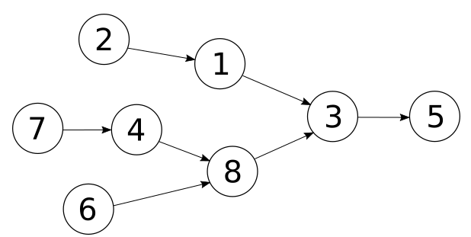

* **Visual left-to-right, top-to-bottom:**

**Sequence: 2,1,3,5,7,4,8,6**

* **Smallest-numbered available vertex first:**

**Sequence: 2,1,3,5,7,4,6,8**

* **Attempting top-to-bottom, left-to-right:**

**Sequence:2,1,7,4,6,8,3,5**

* **Fewest edges first:**

**Sequence:2,1,7,4,6,8,3,5**

* **Largest-numbered available vertex first:**

**Sequence:7,6,8,4,2,1,3,5**

**2.**

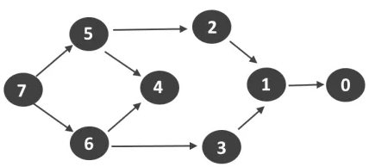

* **Visual left-to-right, top-to-bottom:**

**Sequence: 7,5,2,1,0,6,4,3**

* **Smallest-numbered available vertex first:**

**Sequence:0,1,2,5,7,4,3,6**

* **Attempting top-to-bottom, left-to-right:**

**Sequence:0,1,2,5,7,3,6,4**

* **Fewest edges first:**

**Sequence:**

* **Largest-numbered available vertex first:**

**Sequence:7,5,4,6,3,1,2,0**

**3.**

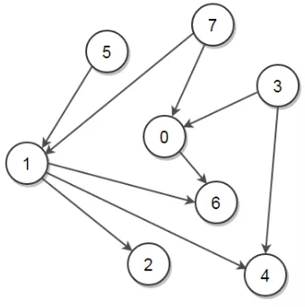

* **Visual left-to-right, top-to-bottom:**

**Sequence: 1,6,4,2,3,0,6,7,5**

* **Smallest-numbered available vertex first:**

**Sequence:1,2,4,6,0,3,5,7**

* **Attempting top-to-bottom, left-to-right:**

**Sequence:3,0,6,4,7,1,2,5**

* **Fewest edges first:**

**Sequence:**

* **Largest-numbered available vertex first:**

**Sequence:1,6,4,2,7,0,5,3**

**4.**

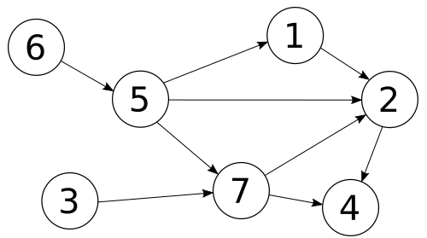

* **Visual left-to-right, top-to-bottom:**

**Sequence: 6,5,1,3,7,2,4**

* **Smallest-numbered available vertex first:**

**Sequence:3,6,5,1,2,7,4**

* **Attempting top-to-bottom, left-to-right:**

**Sequence:6,5,1,2,3,7,4**

* **Fewest edges first:**

**Sequence:6,5,1,2,3,7,4**

* **Largest-numbered available vertex first:**

**Sequence:6,5,7,4,1,2,3**

**5.**

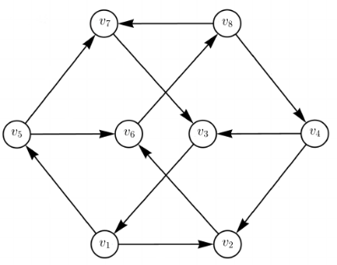

* **Visual left-to-right, top-to-bottom:**

**Sequence: v7,v3,v1,**

* **Smallest-numbered available vertex first:**

**Sequence:**

* **Attempting top-to-bottom, left-to-right:**

**Sequence:**

* **Fewest edges first:**

**Sequence:**

* **Largest-numbered available vertex first:**

**Sequence**